IPA Notepad

Mark McOsker

CS 420

Revision History
Author | Date | Revision
M. McOsker | 9/27/15 | Initial Release
M. McOsker | 10/5/15 | Persistence and Slashing
M. McOsker | 10/26/15 | Sharing

Table of Contents
Vision Statement 4
Requirements 5
Step #1: Identify Categories of Users 5
Step #2: Create Actor-Goal List 5
Step #3: Identify User Stories 6
Step #4: Write Use Cases 7
Release Plan 10
Iteration #1 11
Iteration #1 Review Meeting 12
Iteration #1 Retrospective 12
Design 13
Coding Standards 14
Project Summary and Retrospective 16

Vision Statement
The IPA Notepad is a text editor that will allow students, teachers, and other who are working in the field of communications and sciences disorders to easily type out the phonetic spelling of any words that can be expressed in the English subset of the International Phonetic Alphabet. They will also be able to save anything they type as files that can be shared or the text can be sent directly from the app through various mediums, such as SMS or email. Unlike other IPA text editors this will have the complete set of the English IPA and will be provided at no charge.

Requirements

Categories of Users
Persons in the CSD Field – Those who work in/working on degrees to get into the field of communications and sciences disorders.

Actor-Goal List
Actor | Goal
Person in the CSD Field | Send typed dictation to someone
 | Browse all saved dictions along with the text from the current session, if there is any
 | Save current diction
 | Decide what to name the file, where to save it, and what format
 | Create a diction

User Stories
As a person in the CSD field, I want to type dictions into the primary text editor view
Estimated Effort: 4
When the user presses a button on the keyboard the corresponding character will appear at the cursor position.

As a person in the CSD field, I want to be able to save the dictions I have types
Estimated Effort: 8
The user can either select “Save As…” or “Save” to save the file and the app will bring up a dialog for the user to given the app the info for where to save the file, what to name it, and what format to save it.
As a person in the CSD field, I want the current diction to persist from one session to the next
Estimated Effort: 6
When the user exits the app whatever they have currently typed will be saved to persistent storage and retrieved when the app is reopened.
As a person in the CSD field, I want to be able to format my typed dictions the way I want/need them to be
Estimated Effort: 7
The user can decide how their words are bracketed in the diction.
As a person in the CSD field, I want to be able to send my dictions to other people
Estimated Effort: 10
The user can send any previously saved dictons, or the current diction as simple text, through various mediums, such as SMS and email.
As a person in the CSD field, I want to be able to include non-IPA characters in my dictions so that I can make comments that may be useful to people viewing the diction
Estimated Effort: 12
The user can enter a non-IPA character that will not be effected by the bracketing rules that are present in IPA. The soft keyboard or a separate set of keys will be used for entering the non-IPA characters with some sort of “shift” key to switch between modes.

Product Backlog
Story ID | Story | Story Points | Priority | Status
S1 | As a person in the CSD field, I want to type dictions into the primary text editor view | 4 | 1 | Done
S2 | As a person in the CSD field, I want to be able to save the dictions I have types | 8 | 2 | Done
S3 | As a person in the CSD field, I want the current diction to persist from one session to the next | 6 | 3 | Done
S4 | As a person in the CSD field, I want to be able to format my typed dictions the way I want/need them to be | 7 | 4 | Done
S5 | As a person in the CSD field, I want to be able to send my dictions to other people | 10 | 5 | Done
S6 | As a person in the CSD field, I want to be able to include non-IPA characters in my dictions so that I can make comments that may be useful to people viewing the diction | 12 | 6
S7 | As a person in the CSD field, I want to be able to open previously saved dictions | 2 | 7

Sprint #4
Sprint Backlog
Story ID | Story / Task | Estimated  Hours | Actual  Hours
S6 | Add button to switch to normal keyboard | 1 | 1
 | Add way to exit out of the phones normal keyboard | 1
 | Modify the slashing rules to ignore slashing rules | 5
S7 | Add option to open file | 1
 | Add new interface to the file system to read a file | 1
 | Take file and write its text to the notepad | 2
[Iteration burndown]

Iteration #4 Retrospective
[summary]
Project velocity: 11.6

25
20
15
10
5
1
 | Sprint 1 | Sprint 2 | Sprint 3 | Sprint 4 | Sprint 5 | Sprint 6

Design
[Design Diagram]
[Design Summary]

Sprint #3
Sprint Backlog
Story ID | Story / Task | Estimated  Hours | Actual  Hours
S5 | Add option for sharing to action bar | 1 | 1
 | Implement interface for sharing via SMS | 3 | 2
 | Implement interface for sharing via email, both as attachment and text, if possible. | 3 | 2
 | Add option for saving to other locations | 3 | N/A
 | Implement interface for sharing via cloud apps | 3 | 1

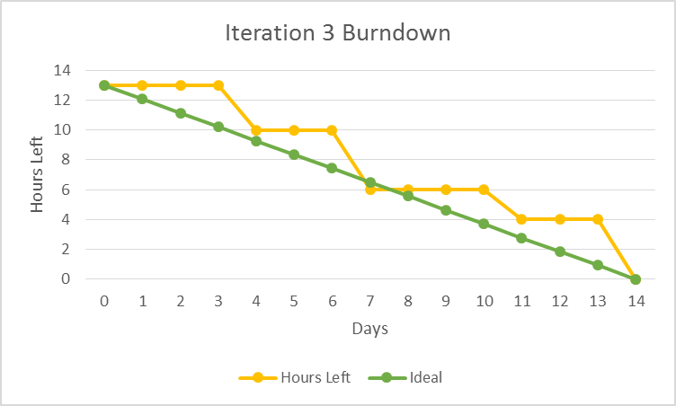

Iteration #3 Retrospective
The implementation for sharing turned out to be easier than expected, if the sharing is just simple text. A lot of time prior was spent on trying to share files. This was very difficult to implement and actually severely limited the app’s utility. Sharing simple text allowed a lot more apps to be used in a simpler way, since files did not need to be moved around as much.
Project velocity: 11.6

25
20
15
10
5
1
 | Sprint 1 | Sprint 2 | Sprint 3 | Sprint 4 | Sprint 5 | Sprint 6

Design
The implementation for sharing was very simple. All that was needed was an additional option added to the options menu, and creating an ‘ACTION_SEND’ intent. There was also some refactoring done in the FileSystem class to writing exclusively to the internal storage since there was no need for the files the app writes to be accessible to other apps. The context of the app is now contained in the Diction app as a private field so it can pass it to the FileSystem class. This shortened the signatures on a few of the Diction’s methods thus making the interface with the class simpler, and since this is the class the Activity classes interact with it has made the app easier to modify and maintain.

Sprint #2
Sprint Backlog
Story ID | Story / Task | Estimated  Hours | Actual  Hours
S3 | Create a listener for the app closing | 1 | 1
 | Store the current diction in a private file on app closing | 2 | 1
 | Read the private file if it exists and load that into the notepad EditText | 2 | 1
S4 | Add option in options menu for settings | 1 | 1
 | Create preferences XML to be used by preference fragment that has the option for bracketing style | 1 | 1
 | Add the preference fragment to the main activity | 2 | 4
 | Implement bracketing within the notepad | 4 | 4
 | Change any current bracketing within the notepad EditText | 2 | 3
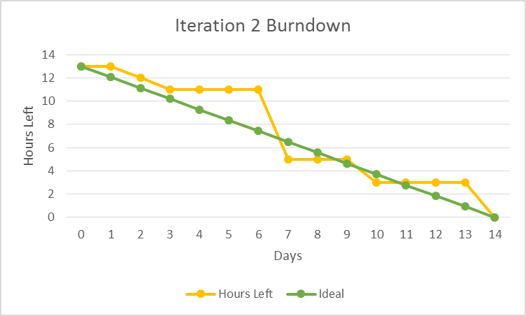

Iteration #2 Retrospective
Getting the logic behind the actual slashing in the diction was easier than thought, although there are still some cases where it is not working properly. Getting the slashing to change when the setting was changed was very difficult since I was unknowingly reloading the previous text whenever the main activity was resume. I will pay more attention to the life cycles of the activities and how they are interacting with one another next time and put some more thorough logging in to make it easier to track down the problems.
Project velocity: 12.5

25
20
15
10
5
1
 | Sprint 1 | Sprint 2 | Sprint 3 | Sprint 4 | Sprint 5 | Sprint 6

Design
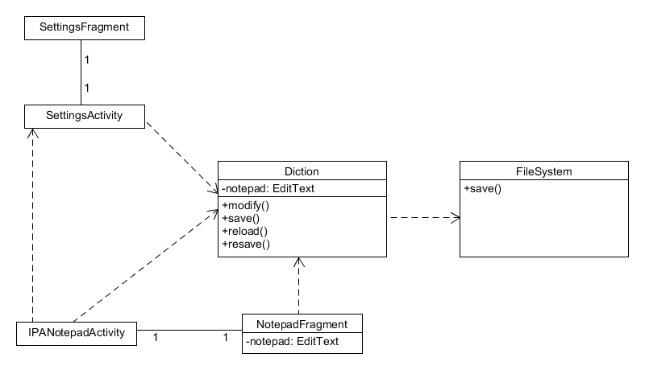
All functionality dealing with how the notepad would behave has been moved into a singleton Diction class. The Diction class also interfaces with the FileSystem singleton to save dictions. This helps simplify the application by having one place to modify the diction, so it is very easy to do from multiple places in the app. The onPause listener is the only other new addition needed to be able implement the feature from S3. The NotepadFragment was also created to further isolate the different parts of the app, and allow for this to be used elsewhere in the future. The preferences were implemented in the standard way for android and simply orchestrate the function calls depending on the preference’s value.

Sprint #1
Sprint Backlog
Story ID | Story / Task | Estimated  Hours | Actual  Hours
S1 | Build string-array resources for keyboard buttons | 1 | 1
 | Build GridView and implement adapter for buttons | 2 | 4.5
 | Implement an OnClickListener for the buttons to modifiy the primary EditText | 2 | 1
 | Add other buttons that won’t fit into the GridView layout and/or have different behavoir | 2 | 4
S2 | Add option in options menu to “Save As…” | 1 | 1
 | Build dialog that receives input from the user on how to save the file | 3 | 2
 | Add option in the options menu to “Save” | 2 | 2
 | Make “Save” option use previously entered data from the Save As… dialog if this file has already been saved and act as the “Save As…” if the file hasn’t been | 3 | 1
 | Build interface that writes the file to phone’s file system | 2 | 2

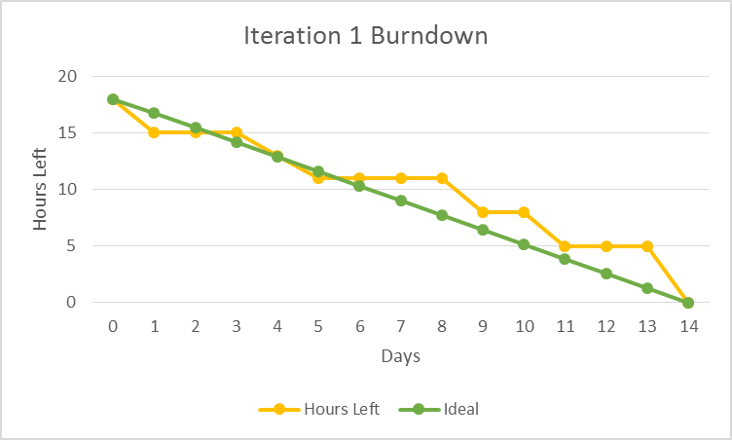

Iteration #1 Retrospective
Building the keyboard was surprisingly easy to do when using an adapter to dynamically build the buttons. The actual layout of the keyboard was a bit difficult to figure out since there is no standard layout for a keyboard like this. The saving of the files was a bit tricky to figure out since there were multiple options for how to save files, along with trying to figure out how to make an interface that would be usable both inside the SaveAsFragment as well as the main activity. I’m going to use more throw away prototypes since modifying the keyboard’s layout in the XML was tedious to do and took a long time to do.
Project velocity: 12

25
20
15
10
5
1
 | Sprint 1 | Sprint 2 | Sprint 3 | Sprint 4 | Sprint 5 | Sprint 6

Design
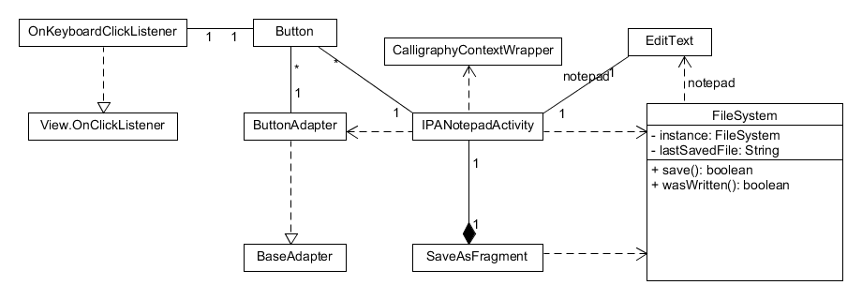
The keyboard was implemented using a ButtonAdapter to build the buttons dynamically based on a string resource file and populate a GridView to make up the major portion of the keyboard. The bottom row, i.e. the one that has the spacebar and backspace were added separately in a LinearLayout positioned right below the GridView that is a part of the keyboard. All of the buttons associated with keyboard had an OnKeyboardClickListener attached that would interface with the EditText that acted as the notepad for the app. This listener handles all of the keys’ inputs and modifies the EditText’s value accorindgly. The FileSystem is used to interface with Android’s file sytem with the SaveAsFragment collecting information needed to save the file if needed, otherwise the SaveAsFragment is bypasses and FileSystem is used directly by the IPANotepadActivity. The CalligraphyContextWrapper is used to give the app a consistent font that doesn’t have uneven weight for non-standard letters.

Coding Standards
- All non-overridden methods must have a doc-block that describes the function, its parameters, and what it returns.
- All indentation will be done in increments of 2 spaces.
- Each brace gets its on line, only comments are allowed to be on the same line.
- All class names will follow pascal casing and all variables will follow camel casing. Any acronyms will only have the first letter capitalized if applicable.’
- All import must be alphabetized and will be grouped as follows, with each group having a blank line separating it from other groups and/or the actual code.
  - Any core java classes
  - Any core android classes
  - Any 3rd party classes
  - Any internal classes
- Non-static methods calls that are called within the class must be called with this. E.g. this.getName(); not getName();.

